

Sri Krishna College of Technology, Coimbatore
An Autonomous Institution |Accredited by NAAC with‘A’Grade
Department of CSE (IOT)

Blockchain-Integrated Steganography with ML-Based
Integrity Checking

Guided by: Ms.S.Soundarya, Assistant Professor, Cybersecurity.
Presented By:  727822TUCY062 | M.VIGNEASH
727822TUCY025 | KAVIYA V S
727822TUCY041 | NISHANTH RAJESH

Department of CSE (IOT)

BASE PAPER DETAILS

- Title: IAAE-Stega: Generic Blockchain-based Steganography Framework via Invertible Adversarial Autoencoder
- Authors: Xiangbo Yuan, Jiahang Sun, Zhuo Chen, Meng Li, Chuan
Zhang, Zijian Zhang, Liehuang Zhu
- Year: 2025
- Journal Details:
- Journal: IEEE Transactions on Network Science and Engineering
- Digital Object Identifier (DOI): 10.1109/TNSE.2025.3577778
- Note: The provided document is the author's version which has not
been fully edited and may change before final publication.

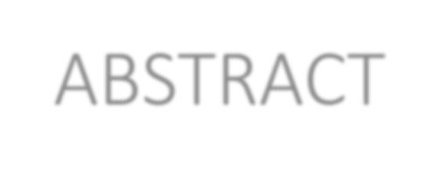
Department of CSE (IOT)
ABSTRACT

- Steganography conceals information but traditional methods suffer from low embedding rate, low concealment, and risk of tampering.

- Blockchain provides anonymity, decentralization, and immutability, making it suitable for covert communication.

- The base framework IAAE-Stega uses an Invertible Adversarial Autoencoder (IAAE) to generate indistinguishable fields while embedding hidden data.

- It enhances efficiency, embedding capacity, and concealment compared to existing GAN-based approaches.

- Our project extends this concept by combining Blockchain logging with ML- based integrity checking for tamper-proof verification in secure data transmission.


Department of CSE (IOT)
INTRODUCTION

  - Steganography enables covert communication by hiding data in carriers like text, images, or video, ensuring secrecy beyond encryption.

  - Traditional schemes face risks such as third-party tampering, compression, monitoring, and identity tracing, reducing reliability.

  - Blockchain introduces anonymity, non-tampering, and decentralization,
making it a powerful medium for secure covert messaging.

  - However, existing blockchain steganography methods struggle with low embedding rate, low concealment, and inefficiency.

  - The IAAE-Stega framework addresses these gaps with an invertible adversarial autoencoder, ensuring efficient, high-capacity, and highly concealed data embedding.

Department of CSE (IOT)
Literature Survey (Existing Technology)

Ref. No | Titlte, Author, Year | Methodology Used | Dataset
1 | Hybrid Blind Img Sec (IEEE'12) | DWT-DCT embed | Sample imgs
2 | IAAE-Stega (IEEE'25) | Blockchain + Autoencoder | Baseline compare
3 | Cybersecure Smart Cities (IEEE) | Blockchain framework | --

Department of CSE (IOT)
Literature Survey (Existing Technology)

Ref. No | Titlte, Author, Year | Methodology Used | Dataset
4 | Stego Methods Compare (IEEE) | Spatial vs Transform
5 | DL + Traditional Stego Survey (IEEE) | Stego overview | Lit review
6 | Blockchain in Smart Grid (IEEE) | Blockchain + cybersecurity | Survey

Department of CSE (IOT)
Literature Survey (Existing Technology)

Ref. No | Titlte, Author, Year | Methodology Used | Dataset
7 | Double-Layer Stego + BC (Springer) | Stego + blockchain | --
8 | BC + DL for Data Quality (Springer'24) | Blockchain + DL | Txn logs
9 | DL Stegomalware Sanitizer (Springer'25) | DL for image malware cleanup | Img set
10 | IoT Sec Survey  (Springer'23) | ML + BC + Crypto +  Quantum | Review

Department of CSE (IOT)
Literature Survey (Existing Technology)

Ref. No | Titlte, Author, Year | Methodology Used | Dataset
11 | EV Load via BC + FL (Springer'25) | FL + Blockchain | EV logs
12 | Tangle + Img Encrypt for IoT (Springer'23) | DAG chain + novel enc | IoT imgs
13 | RDH + BC in E-Health (Elsevier) | Interpolation RDH + blockchain

Department of CSE (IOT)
Literature Survey (Existing Technology)

Ref. No | Titlte, Author, Year | Methodology Used | Dataset
14 | xDoG Stego + BC Auth (Elsevier'25) | Edge-guided embed + BC | Auth test
15 | AI + BC in Industry 4.0 (Elsevier'24) | AI + BC review | Lit review


Department of CSE (IOT)
PROBLEM DEFINITION

- Traditional steganography techniques are vulnerable to tampering, detection, and tracing, compromising secrecy.

- Blockchain-based steganography improves anonymity and immutability but suffers from low embedding rate and poor concealment.

- Extra fields in blockchain transactions often expose hidden data patterns,

increasing the risk of detection.

- GAN-based approaches offer concealment but face low efficiency, limited capacity, and high computational cost.

- There is a need for a generic, efficient, and tamper-proof steganography framework that balances embedding capacity, concealment, and security.

Department of CSE (IOT)

CHANGES MADE IN THE EXISTING SYSTEM

Feature / Component | Existing System (Phase-1) | Proposed System (Phase-2)
Steganography Media Usage | Single-media steganography (only image or only blockchain field) | Cross-media steganography where the secret is distributed across image pixels and blockchain transaction metadata
Payload Organization | Secret embedded as a single continuous payload | Payload fragmentation across media, where each fragment alone is meaningless without reconstruction
Embedding Dependency | Independent embedding per carrier | Inter-dependent embedding, where blockchain metadata is required to reconstruct image-embedded data
Key Generation Method | Classical pseudo-random or static  symmetric key | Quantum-inspired key generation using simulated QKD principles (BB84- style random bit generation)
Key Usage Pattern | Same key reused across sessions | One-time session keys derived from  quantum-generated bitstreams
Key-to-Embedding Mapping | Key used only for encryption | Quantum key controls fragment order,  embedding locations, and  reconstruction sequence
Security Model | Security relies on obscurity of a single carrier | Multi-layer security combining cross- media dependency and quantum-key- driven embedding logic

Department of CSE (IOT)

CHANGES MADE IN THE EXISTING SYSTEM

Steganography Media Usage Phase-1 (Existing System):
The system hides the entire secret message inside a single carrier—either an image or a blockchain transaction field. If that carrier is detected, compressed, or analyzed, the complete hidden information becomes vulnerable.

Phase-2 (Proposed System):
The system adopts cross-media steganography, where the secret data is distributed across two different carriers:
Image pixels (stego image)
Blockchain transaction metadata (hashes or identifiers)
This separation ensures that no single medium contains sufficient information to reveal the secret, significantly increasing security while remaining software- implementable.

Department of CSE (IOT)

CHANGES MADE IN THE EXISTING SYSTEM

Payload Organization Phase-1:
The secret data is embedded as a single continuous payload, meaning it can be
fully reconstructed if the embedding carrier is compromised.

Phase-2:
The payload is fragmented into multiple parts, and each fragment is embedded in a different medium. Each fragment is meaningless on its own and requires correct reconstruction order and key information to recover the original data.
This fragmentation improves robustness and prevents partial data leakage.

Department of CSE (IOT)

CHANGES MADE IN THE EXISTING SYSTEM

Embedding Dependency Phase-1:
Each carrier (image or blockchain field) is embedded independently. The extraction process does not require cross-referencing between carriers. Phase-2:
The embedding process becomes inter-dependent. Blockchain metadata stores references such as:
Fragment indices Hash pointers
Reconstruction order identifiers
Without access to blockchain metadata, image-embedded data cannot be reconstructed, enforcing a dependency between carriers.

Department of CSE (IOT)

CHANGES MADE IN THE EXISTING SYSTEM

Key Generation Method Phase-1:
Keys are generated using classical pseudo-random number generators or fixed
symmetric keys, which may be reused across sessions.

Phase-2:
The system uses quantum-inspired key generation, where unpredictable bitstreams are generated by simulating QKD (BB84-style) principles in software. Although no real quantum hardware is involved, this method ensures:
High entropy
Unpredictable key sequences One-time usability
This makes the system resistant to classical key-prediction attacks.

Department of CSE (IOT)

CHANGES MADE IN THE EXISTING SYSTEM

Key Usage Pattern Phase-1:
A single key is reused for multiple embedding and extraction sessions, increasing
exposure to replay or brute-force attacks.

Phase-2:
Each communication session uses a one-time session key derived from the quantum-generated bitstream. Once a session ends, the key is discarded.
This eliminates key reuse and strengthens forward secrecy without adding heavy computational overhead.

Department of CSE (IOT)

CHANGES MADE IN THE EXISTING SYSTEM

Key-to-Embedding Mapping Phase-1:
The cryptographic key is used only for encrypting the secret data before
embedding.

Phase-2:
The quantum-generated session key controls multiple embedding parameters, including:
Fragment embedding order
Pixel or block selection within the image Reconstruction sequence at the receiver
This tight coupling between key and embedding logic ensures that even if the stego media is extracted, reconstruction remains impossible without the correct key.

Department of CSE (IOT)

CHANGES MADE IN THE EXISTING SYSTEM

Security Model Phase-1:
Security relies primarily on the obscurity of a single carrier and basic
cryptographic protection.

Phase-2:
A multi-layer security model is introduced, combining:
Cross-media data dependency Quantum-inspired one-time keys
Controlled embedding and reconstruction logic
An attacker must simultaneously compromise both media and the session key, making practical attacks computationally infeasible.


Department of CSE (IOT)

PROPOSED SYSTEM/METHODOLOGY
- Steganography Embedding: Secret data is embedded into cover media (images/videos) using advanced embedding algorithms.

- Hash Generation & Blockchain Logging: A hash of the hidden data is computed and stored on the blockchain, ensuring immutability and tamper-proof verification.

- Invertible Adversarial Autoencoder (IAAE): Enhances embedding rate, concealment, and efficiency by generating indistinguishable extra fields in transactions.

- ML-based Integrity Checking: Machine learning models analyze stego media to detect manipulation, corruption, or attacks.

- End-to-End Workflow: Data hiding → blockchain logging → transmission → extraction → hash verification → ML validation ensures secure and verifiable covert communication.


Department of CSE (IOT)
CHANGES MADE IN THE EXISTING SYSTEM

  - Integrated Blockchain Hash Logging to ensure immutability and tamper- proof verification of hidden data.

  - Added Machine Learning–based Integrity Checking for automated detection of data tampering beyond blockchain verification.

  - Extended support from purely transactional fields (as in IAAE-Stega) to
cover media (images/videos) for broader applicability.

  - Designed an end-to-end workflow with embedding, transmission, verification, and extraction for practical deployment.

  - Enhanced alignment with SDG goals and IKS integration, enabling
secure, sustainable, and culturally rooted data communication.

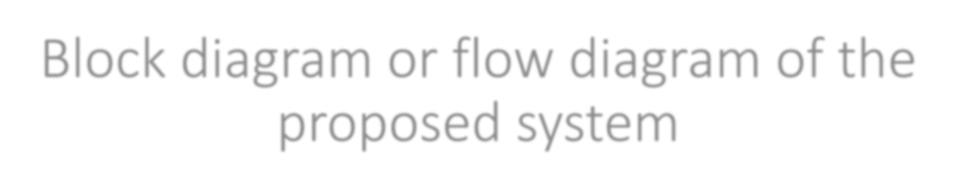
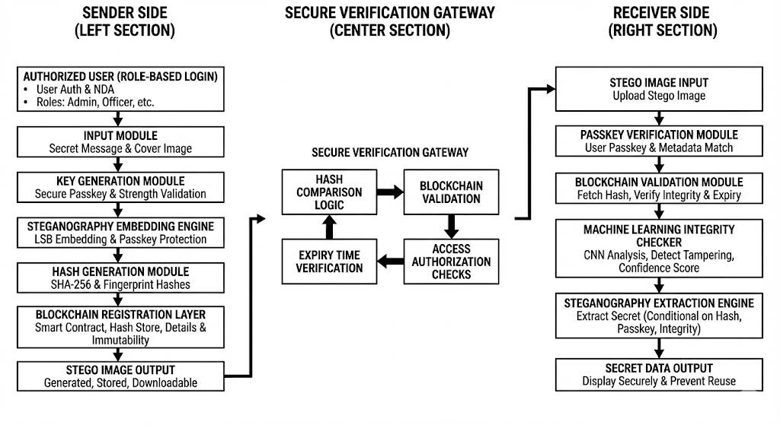
Department of CSE (IOT)

Block diagram or flow diagram of the proposed system


Department of CSE (IOT)
DATASET/PROCEDURE

- Dataset Collection: Bitcoin blockchain transaction fields (output amounts, fees, gas limits) are used as data sources for embedding and verification.

- Preprocessing: Transaction values are normalized using min–max scaling to
prepare input vectors for the autoencoder model.

- Embedding Process: Secret data is encoded via the Invertible Adversarial Autoencoder (IAAE) and hidden into blockchain fields or cover media.

- Verification Stage: Blockchain stores hashes of hidden data for immutability; ML
models check for tampering or abnormal patterns.

- Extraction & Validation: Receiver decodes embedded fields/media, recalculates hash, and compares with blockchain + ML results to ensure integrity.

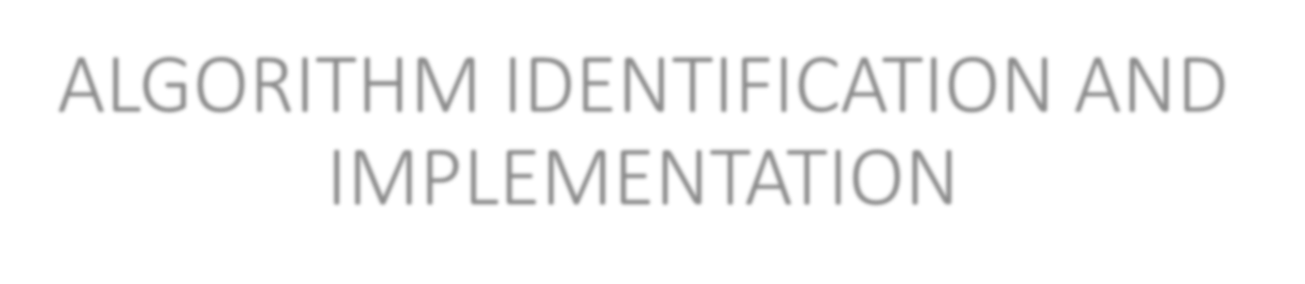
Department of CSE (IOT)
ALGORITHM IDENTIFICATION AND
IMPLEMENTATION

- Invertible Adversarial Autoencoder (IAAE): Core algorithm used for embedding/extraction, ensuring high concealment and reversibility.

- Encoder–Decoder Process: Encoder hides secret data into blockchain/cover media
fields; decoder reconstructs hidden data with minimal error.

- Discriminator Network: Enhances concealment by distinguishing between real blockchain fields and autoencoder-generated fields.

- Hashing Algorithm: Cryptographic hash (e.g., SHA-256) generates tamper-proof
signatures stored on blockchain for verification.

- ML Integrity Models: Classification models analyze stego media for anomalies, supporting automated tamper detection.


Department of CSE (IOT)
MODULAR DESCRIPTION

  - Data Collection & Preprocessing Module
  - Steganography Embedding Module
  - Blockchain Hash Logging Module
  - Transmission & Reception Module
  - Data Extraction Module
  - Hash Verification Module
  - ML-based Integrity Checking Module
  - Result & Decision Module


Department of CSE (IOT)
Data Collection & Preprocessing Module

- Data Sources – The system collects cover media such as images or videos, and blockchain transaction fields (e.g., fees, gas limits, or output amounts). These act as carriers for embedding hidden data.
- Normalization – Raw data values are scaled into a standard range using min–max normalization. This prepares inputs for the autoencoder and prevents bias during training.
- Cleaning – Any irrelevant, duplicate, or noisy data is removed to ensure consistency and improve the accuracy of later processing steps.
- Dataset Preparation – Data is split into training, testing, and validation subsets, ensuring the ML model and autoencoder are trained efficiently and evaluated fairly.

Department of CSE (IOT)

Steganography Embedding Module

- Secret Selection – Users provide the confidential message or data to be hidden
securely inside the carrier medium.
- Embedding Process – The system hides this data using steganography algorithms, enhanced by the Invertible Adversarial Autoencoder (IAAE) for efficient and reversible embedding.
- Concealment – Embedded data remains invisible to human eyes and difficult for attackers or detection algorithms to identify, ensuring covert transmission.
- Reversibility – The embedding method guarantees that the hidden message can be fully and accurately recovered at the receiver’s side.


Department of CSE (IOT)
Blockchain Hash Logging Module

- Hash Generation – A cryptographic hash (e.g., SHA-256) of the secret data is generated to act as a digital fingerprint of the hidden content.
- Blockchain Storage – The hash is stored in a blockchain ledger, ensuring immutability and decentralized verification of the hidden message.
- Immutability – Once logged, the hash cannot be altered or deleted, making it resistant
to tampering and providing long-term trust.
- Audit Trail – This process creates a permanent record of hidden communications, offering transparency and a reliable trail for verification when needed.


Department of CSE (IOT)
Transmission & Reception Module

- Stego Transmission – The stego media (image, video, or blockchain transaction) containing the hidden data is transmitted across public or untrusted networks.

- Covert Channel – The transmission mimics normal communication, allowing it to bypass censorship and avoid drawing suspicion.

- Receiver Access – The intended receiver collects the stego media using regular network activity or by accessing the blockchain ledger.

- Secure Delivery – As no direct sender–receiver connection is required, the system reduces traceability while still ensuring reliable delivery of the message.


Department of CSE (IOT)
Data Extraction Module

- Reception – The authorized receiver feeds the obtained stego media into the
extraction algorithm for analysis.
- Decoding – The inverse embedding algorithm (decoder of IAAE) is applied to recover the hidden secret data.
- Accuracy – Extraction ensures the retrieved message remains intact and free from major errors, even after network transmission.
- Output – The decoded message is presented in its original form, ready for further integrity checks.


Department of CSE (IOT)
Hash Verification Module

- Recalculation – A fresh cryptographic hash is generated from the extracted hidden data.
- Comparison – The recalculated hash is matched against the original hash stored on the blockchain.
- Validation – If the two hashes match, the message is confirmed as authentic and
untampered.
- Tamper Detection – If there is a mismatch, the data is flagged as compromised, signaling corruption or malicious manipulation.


Department of CSE (IOT)
ML-based Integrity Checking Module

- Anomaly Detection – Machine learning models analyze stego media for irregularities, distortions, or patterns of manipulation.
- Automation – Integrity checking is automated, reducing reliance on manual inspection and enabling faster responses to attacks.
- Robustness – Models are trained to recognize advanced tampering techniques,
making the system resistant to modern steganalysis.
- Complementary Check – This step adds a second line of defense by verifying media integrity even if blockchain verification passes.


Department of CSE (IOT)
Result & Decision Module

- Integration – Combines outcomes from blockchain verification and ML integrity
checking to form a final decision.
- Decision Making – Accepts data if both checks pass, or rejects/flags it if any irregularities are detected.
- User Output – Provides clear results to the user, typically as “Secure” or
“Compromised.”
- Reporting – Generates logs and reports for auditing, enabling transparency and future analysis of secure communications.

Embedding Capacity

EVALUATION CRITERIA
Department of CSE (IOT)


  - Measures how much secret data can be hidden inside the cover medium (images, videos, or
blockchain fields).
  - Higher embedding capacity ensures practical usability without sacrificing quality.

Concealment & Imperceptibility
  - Evaluates how well the hidden data is concealed without being visually or statistically detectable.
  - Stego media should appear identical to normal media to avoid suspicion.

Security & Tamper Resistance
  - Assesses robustness against tampering, detection, and steganalysis attacks.
  - Blockchain immutability and ML-based integrity checks ensure that any modification is quickly identified.

Efficiency & Reliability
  - Focuses on the computational performance and accuracy of embedding, extraction, and verification.
  - Ensures the system is scalable and practical for real-world secure communication.


Department of CSE (IOT)
DETAILS ABOUT THE PLATFORM

- Programming Environment – Developed in Python, making use of libraries like TensorFlow/PyTorch for deep learning and steganography, and web3.py for blockchain integration.
- Blockchain Platform – Uses Ethereum testnet (or Hyperledger Fabric) to log cryptographic hashes, ensuring immutability, decentralization, and tamper-proof verification.

Machine Learning Tools – Employs scikit-learn and Keras/TensorFlow
to build ML models for anomaly detection and integrity verification.
- System Requirements – Runs on Windows/Linux with 8GB+ RAM, standard CPU/GPU support, and blockchain client tools (e.g., Ganache, Geth) for testing and deployment.


Department of CSE (IOT)
EXPECTED RESULT

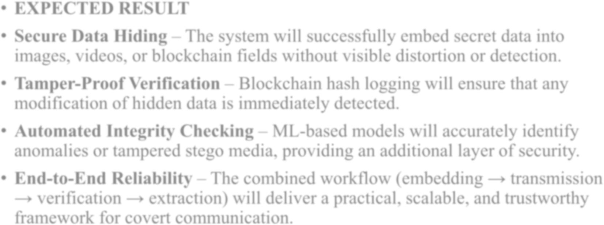
EXPECTED RESULT
- Secure Data Hiding – The system will successfully embed secret data into images, videos, or blockchain fields without visible distortion or detection.
- Tamper-Proof Verification – Blockchain hash logging will ensure that any
modification of hidden data is immediately detected.
- Automated Integrity Checking – ML-based models will accurately identify anomalies or tampered stego media, providing an additional layer of security.
- End-to-End Reliability – The combined workflow (embedding → transmission
→ verification → extraction) will deliver a practical, scalable, and trustworthy
framework for covert communication.


Department of CSE (IOT)
CONCLUSION

- Enhanced Security – The proposed system ensures secure covert communication by combining steganography with blockchain and machine learning.
- Tamper Detection – Blockchain immutability and ML-based integrity checks provide strong protection against data manipulation and unauthorized access.
- Improved Efficiency – The use of the Invertible Adversarial Autoencoder (IAAE) increases embedding capacity and concealment compared to traditional methods.
- Real-World Applicability – The framework can be applied in domains like government, healthcare, defense, and smart cities, where secure and hidden communication is essential.

Department of CSE (IOT)

References & Review Queries
  - Kandasamy, L., and A. Ajay. “Implementation of Blockchain Technology for Secure Image Sharing Using Double Layer Steganography.” In Advances in Intelligent Systems, Computer Science and Digital Economics IV, LNDECT 158, 186–95. Cham: Springer, 2023.
  - Bekkali, A. E., M. Essaaidi, and M. Boulmalf. “A Blockchain-Based Architecture and Framework for Cybersecure Smart Cities.” IEEE Access 11 (2023): 76,359–70.
  - Yuan, X., et al. “IAAE-Stega: Generic Blockchain-Based Steganography Framework via Invertible Adversarial Autoencoder.” IEEE Trans. on Network Science and Engineering (2025).
  - Li, J., and H. Wu. “Blockchain and Deep Learning Technology for Comprehensive Improvement of Transaction Information Quality.” Electronic Commerce Research (2024).

Department of CSE (IOT)

References & Review Queries
  - Mahasree, M., N. Puviarasan, and P. Aruna. “Interpolation-based Reversible Data Hiding with Blockchain for Secure e-Healthcare Systems.” In Blockchain Applications for Healthcare Informatics, edited by Sudeep Tanwar, 373–400. Academic Press, 2022.
  - Patwari, B., U. Nandi, S. Dey, S. Dhar, S. K. Ghosal, and T. Si.
“Blockchain-Integrated Image Steganography using xDoG Edge Detection for Authentication.” Cyber Security and Applications 100091 (2025). doi:10.1016/j.csa.2025.100091.
    - Soori, M., R. Dastres, and B. Arezoo. “AI-Powered Blockchain Technology in Industry 4.0, a Review.” Journal of Economy and Technology 1 (2023): 222–
41. doi:10.1016/j.ject.2024.01.001.
  - Liguori, A., M. Zuppelli, and D. Gallo, et al. “A Deep Learning-Based Approach for Stegomalware Sanitization in Digital Images.” Journal of Intelligent Information Systems, 2025. doi:10.1007/s10844-025-00936-6.

Department of CSE (IOT)

References & Review Queries
  - Cherbal, S., A. Zier, S. Hebal, et al. “Security in Internet of Things: A Review on Approaches Based on Blockchain, Machine Learning, Cryptography, and Quantum Computing.” Journal of Supercomputing 80 (2024): 3,738–3,816.
  - Jin, R., and H. Liu. “Privacy-Aware Electric Vehicle Load Forecasting via Blockchain-Based Federated Transfer Learning.” Complex & Intelligent Systems 11 (2025): 376.
  - Suthar, A. C., C. B. Patel, and G. R. Kulkarni. “Simulation and Implementation Novel Hybrid Blind Method of Image Security.” In ARTCom 2012, Bangalore, 202–5. IEEE, 2012.
  - Shehada, D., and A. Bouridane. “A Comparative Analysis of Image Steganography Techniques in Spatial and Transform Domains.” In DASC/PiCom/CBDCom/CyberSciTech, Abu Dhabi, 2023, 155–60.
  - AbdelRazik, H. F., A. S. ELSayed, S. S. Ismail, and A. M. Mahmoud.
“Traditional and Deep Learning Techniques in Image Steganography: Recent Advances.” In ICICIS 2023, Cairo, 2023, 38–44.

Department of CSE (IOT)

References & Review Queries
  - B., R., and N. Makhija. “Secured Image Storage and Transmission Technique Suitable for IoT Using Tangle and a Novel Image Encryption Technique.” Multimedia Tools and Applications 82 (2023): 36,793–36,814.
  - Zhuang, P., T. Zamir, and H. Liang. “Blockchain for Cybersecurity in Smart Grid: A Comprehensive Survey.” IEEE Trans. Industrial Informatics 17, no. 1 (2021): 3–19.

